Kiosk Disconnected from the Internet

⚠️ Network Connectivity Advisory: Ethernet vs Wi-Fi for Evolt Kiosks

Recommended Network Configuration
Evolt strongly recommends that all kiosks be connected via Ethernet. While Wi-Fi connectivity is supported, it is provided on a best-effort basis only.

Key Considerations
- Reliability: Ethernet offers a more stable and consistent connection, which is essential for optimal kiosk performance.
- Troubleshooting: If a kiosk is experiencing connectivity issues while on Wi-Fi, we recommend relocating it temporarily to a location where it can be connected via Ethernet. If the issues are resolved without any configuration changes, the root cause is likely related to Wi-Fi.

Known Wi-Fi Limitations
- Database Corruption: In some cases, high-latency Wi-Fi environments have caused database corruption within the kiosk, resulting in a “white screen” error.
- Signal Strength vs. Coverage: Even if the site has strong overall internet connectivity, the radio signal strength at the kiosk’s physical location may be weak. This can lead to poor or intermittent connectivity.
  - Solution: Try relocating the kiosk closer to a Wi-Fi access point to improve signal strength and stability.

Summary
For best performance and to minimize support issues:
- Use Ethernet whenever possible
- Use Wi-Fi only when Ethernet is not feasible, and be aware of its limitations
- Relocate the kiosk for testing if Wi-Fi issues are suspected
- Push back on sites where Wi-Fi is proving to be a barrier to support, until the Kiosk can be relocated to a position where Ethernet is present. If only for a short period for diagnostics to occur

Step-by-Step Instructions
- Open Network Settings
  - From the Control Panel, press the Network button.
- Wi-Fi Connection
  - Ensure Wi-Fi is turned ON.
  - Confirm that the New Connection button is visible under Wi-Fi.
  - Check that the Wi-Fi dongle is securely plugged into one of the four USB ports located under the screen at the back of the unit.
  - Press New Connection, select the desired network, and enter the password.
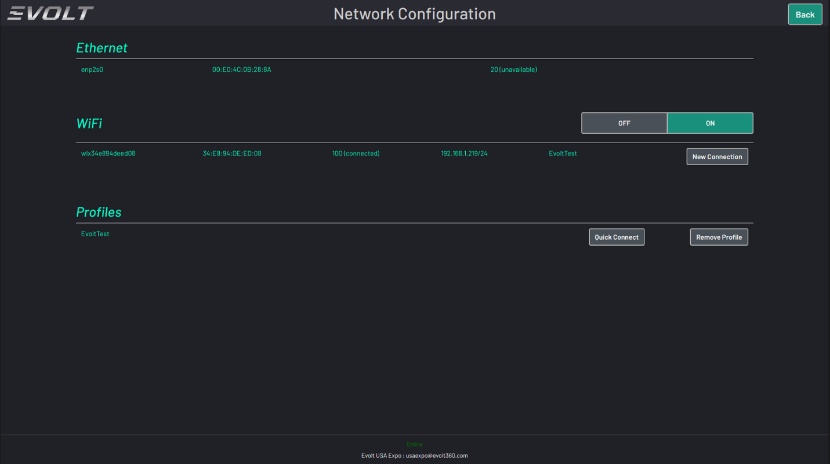
  - Once connected, the status should show 100 (connected) and save the profile under Quick Connect.

- Ethernet Connection
  - Plug the Ethernet cable into the Ethernet port at the back of the unit.
  - The scanner should automatically connect without additional configuration.

